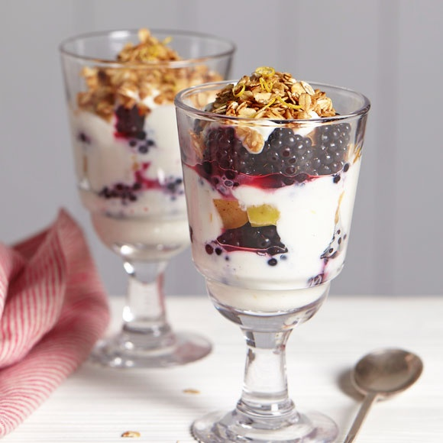
The blackberry cranachan
alcohol-free

The blackberry cranachan is a traditional Scottish dessert marrying oats, whisky, blackberries and cream.

Ingredients :

50g of jumbo porridge oats
25g of soft brown sugar
150g of clotted cream or extra thick cream
2 tablepsons of apple juice
250g of blackberries

Recipes :

Mix the oats and sugar together and spread them out on a backing sheet. Place the sheet under a medium-hot grill. Cook until the sugar has caramelized, stirring the mixture from the grill and set aside to cool.
Pour the cream into a large bowl, add the apple juice and stir until smooth. Loosly break up the cooled oat mixture between your fingers and add most of the crunchy oats to the cream, reserving a few tablespoons for the top.
Place some of the berries in the bottom of 2 glasses. Spoon a dollop of the cream over the top and then repeat the layers of fruit and cream a second time, finnishing with the remaining blackberries.
To finish, sprinkle over the reserved oat mixture and drizzle with a little more apple juice, if required.

